# Tracmap Utilities Tool User Guide

The Tracmap Utilities tool was developed by Gary Eason to streamline the transfer of data from helicopters equipped with the Tracmap GPS system to a computer in the field to enable the monitoring of where bait has been spread during an aerial pesticide operation.

*NB An advanced (arcinfo) licence is required to use this tool, specifically the feature vertices to points tool used to create the secondary lines as well as the function used to add the empty feature classes and tables to the new file geodatabase or new feature classes and tables to an existing file geodatabase.*

**PREPARATION BEFORE THE DAY**

## *Copy the Tracmap Utilities Tool on Your D Drive*

Before using the tool, you will need to load it on to your local D drive (because the parameters file is overwritten each time the setup code is run). The current iteration of the tool is in a directory called Tracmap_Utilities in \\wgnhosvr1\gis$\GIS\Tools. The Tracmap_Utilities directory also contains some sample data to use while familiarising yourself with the tool. Copy the whole directory to your D drive.

Tip: Placing the directory in the home folder from which you will be working in the field (e.g. D:\Aerial_Pest_Control) will make it easy to run the tool from the Catalog window.

NB: You must run the tool from within ArcMap *not* Catalog!

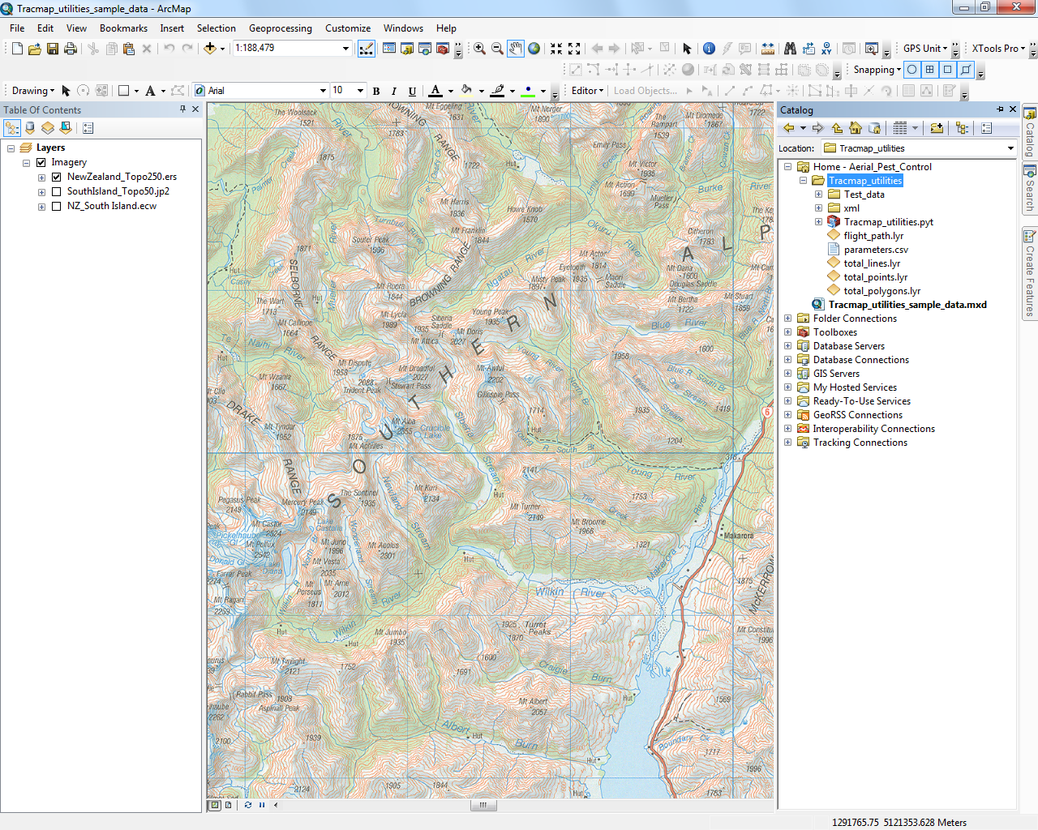

## *Ensure the Treatment Area feature class for your operation has the required fields:*

## ‘HeliBlkNm’ – This field must contain a unique block name per block, which exactly matches the names used in the same field in the shapefile provided to the helicopter company. Alternatively, you can use the same shapefile you have supplied to the helicopter company as your input ‘Treatment Area’. This will ensure the fields match. These field must match as the model uses the field name to look for the folder (blockname) in the raw data.

* 1. ‘Hectares’

*NB - The treatment area input is only required if you want to be able to get the dissolved area. You can run the model without this input by leaving it blank.*

## *Set the Geoprocessing Background*

1. In ArcGIS, open the Geoprocessing menu then select Geoprocessing Options.

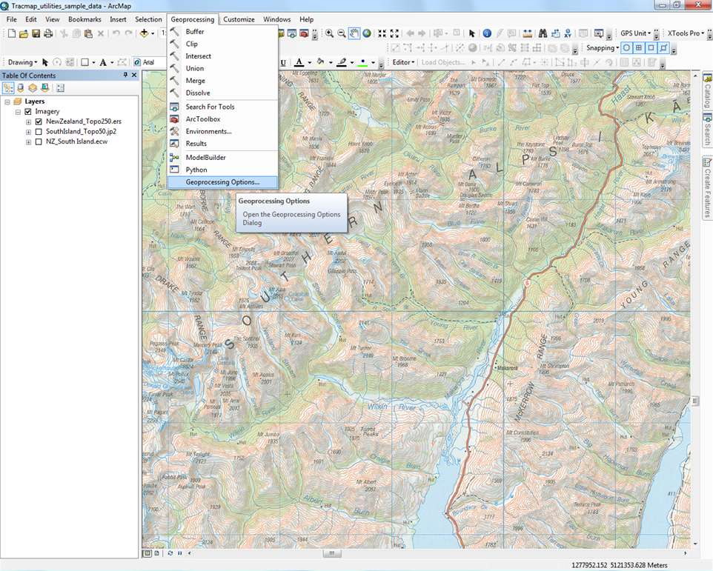

1. In the Geoprocessing Options dialog box, untick the Enable box in the Background Processing section.

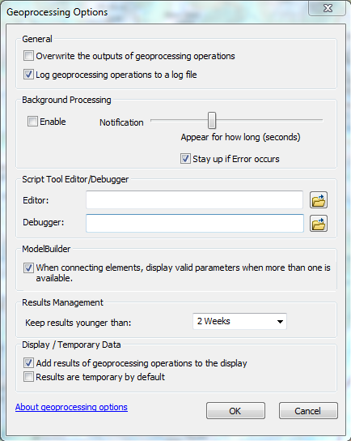

## *Set the Project Coordinate System*

Check that the coordinate system of the data frame you are going to add the data to is set to NZTM. This will enable the incoming data to be transformed on the fly.

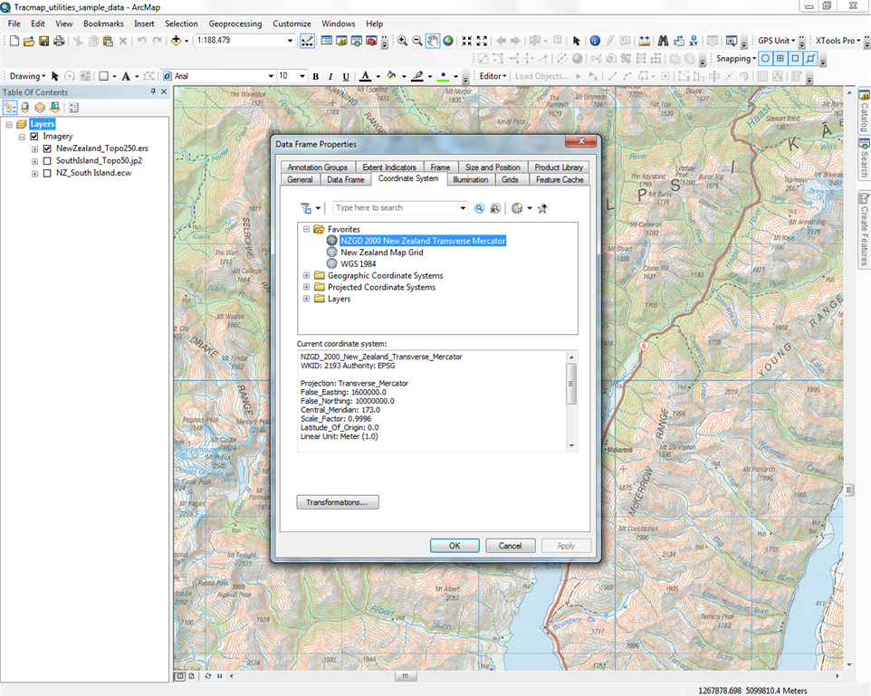

## *Confirm specifications with site supervisor as much as possible*

* 1. If trickle buffer is not to be 15m (total width of 30m) then edit the script (replace 15 with new number at approx. line 578). This can be done by opening the script by right clicking on the tool box and selecting edit. Under the edit menu in notepad you can select ‘Go To…’ and then type in the line you need to get to. In this case its line 578.

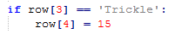

* 1. This tool doesn’t allow for boundary/parallel buffers to be different to the broadcast ones so try to find out beforehand if the site supervisor will want different buffers. If so, then write these down and familiarise yourself with the instructions (at end of this doc) on how to allow for this. The table below shows the settings the script uses

|  |  |  |  |
| --- | --- | --- | --- |
| **Helicopter data** | **Attributes in processed data** | | |
| **Width** | **Bucket** | **BufferType** | **Buffer** |
| >= 120 | Broadcast | Round | Width/2 |
| >= 40 and < 120 | Narrow | Round | Width/2 |
| >= 4 and < 40 | Trickle | Square | 15 |
| > 0 and < 4 | Sprayboom | Square | Width/2 |

* 1. Confirm helicopter IDs, buckets, pilots, capacity etc and write these down. Can be different to what is in the SOW.
  2. Provide picture of Tracmap default settings (page 30 of BFOB user guide) to helicopter rep and ask that these are set on all helicopters. It’s important that the files are **not zipped**, that they are in **WGS84** and that they export the data as **lines**.

## *Set Up the Tool*

1. Open the Catalog window then double-click on the “Copy Tracmap Data” script in the Tracmap_utilities toolbox.
2. In the Copy Tracmap Data dialog box, in the “Drive or folder containing the Tracmap data to copy” box, enter (or navigate to) the pathway for the appropriate drive or folder. The first time you run this tool to do the setup, it doesn’t matter much where you point this first field.

Tip: When working in the field this will be your USB/removeable disk drive (e.g. E:\). When working in the office it will be the ***second lowest*** folder (typically a folder named with a 3-letter helicopter registration code or time) in whatever folder structure the raw Tracmap data has been saved in.

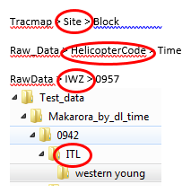It’s really important to point to the right level folder, here are a few examples indicating which folder to point the tool to:

(in this example the ‘Block’ folder contains the log.shp)

(in this example the ‘Time’ folder contains the log.shp)

(in this example the ‘0957’ folder contains the log.shp)

(in this example the ‘western young’ folder contains the log.shp)

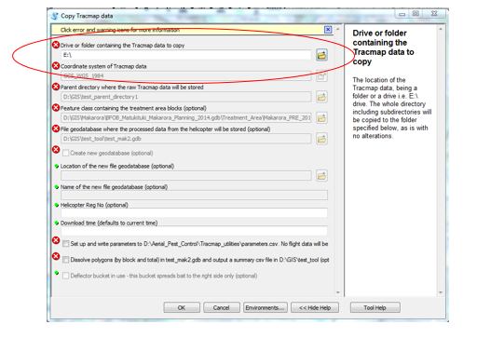

1. Tick the “Set up and write parameters to D:\Aerial_Pest_Control\Tracmap_utilities\parameters.csv.” box.

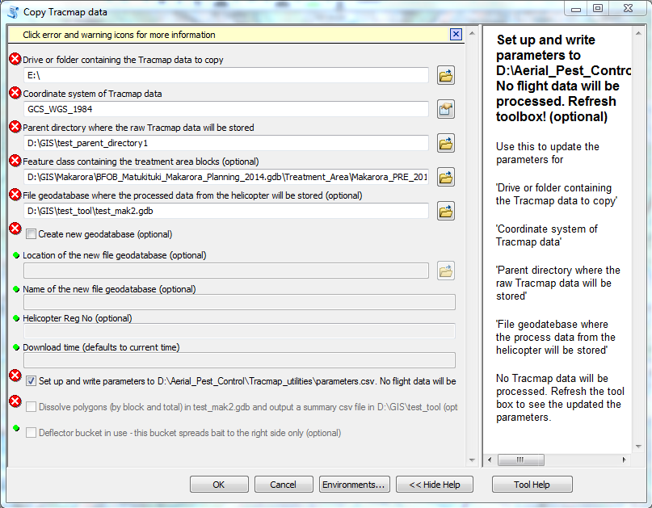

1. In the “Parent directory where the raw Tracmap data will be stored” box, enter (or navigate to) the appropriate parent directory.

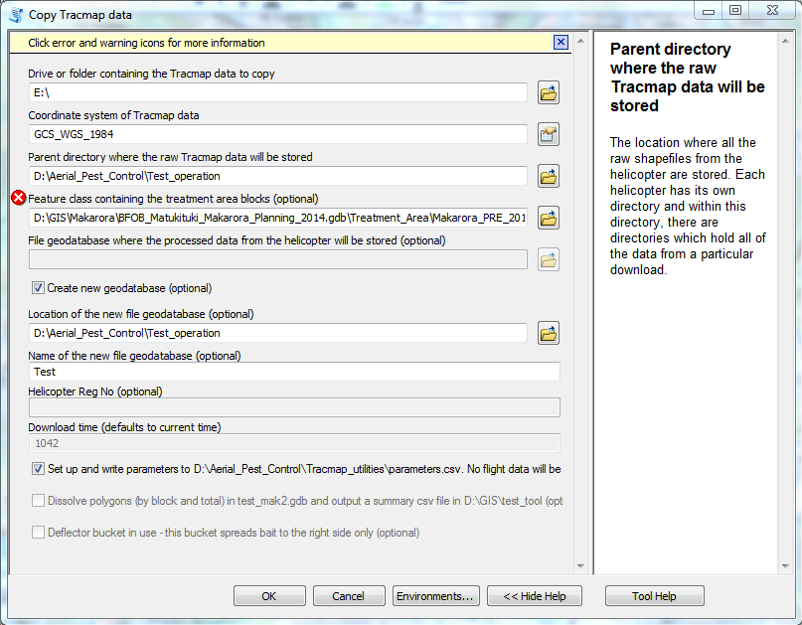

1. In the “Feature class containing the treatment area blocks” box, enter (or navigate to) the name of the treatment area feature class.

NB This is where you will need to have the field block names right or use the helicopter shapefile as your input to insure the fields match. See step 2.

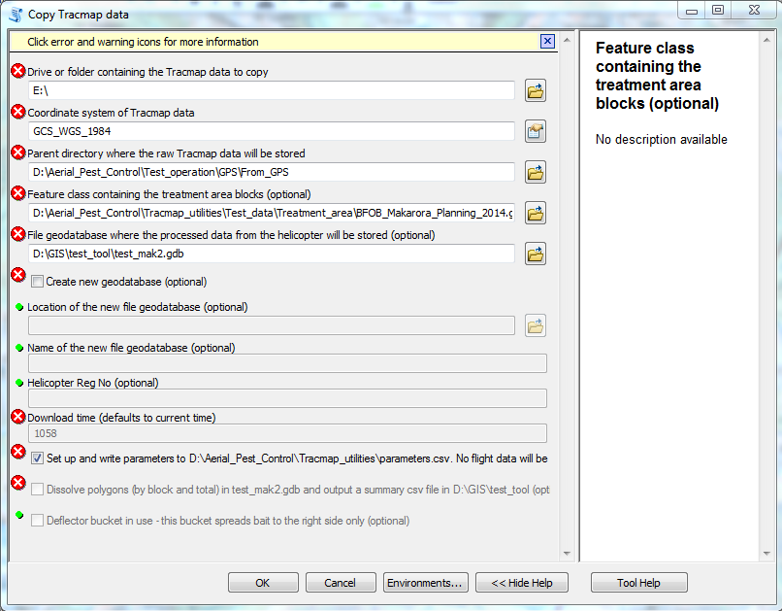

1. Tick the “Create new geodatabase” box.

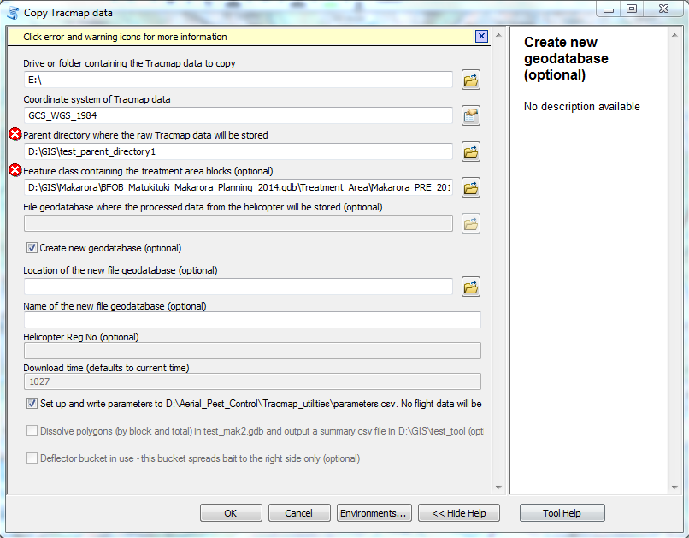

1. In the “Location of the new file geodatabase” box, enter (or navigate to) the pathway for the folder that the geodatabase will be stored in.

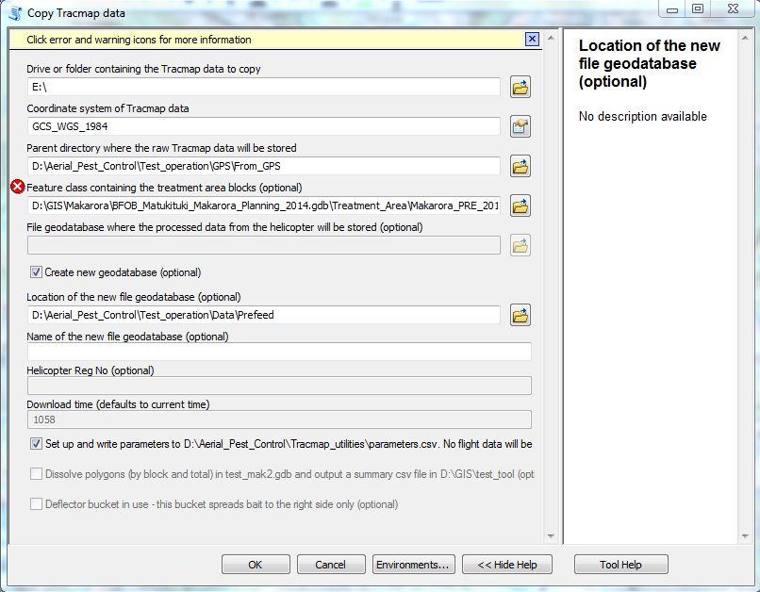

1. In the “Name of the new file geodatabase” box, enter the name of the new geodatabase (without the .gdb suffix).

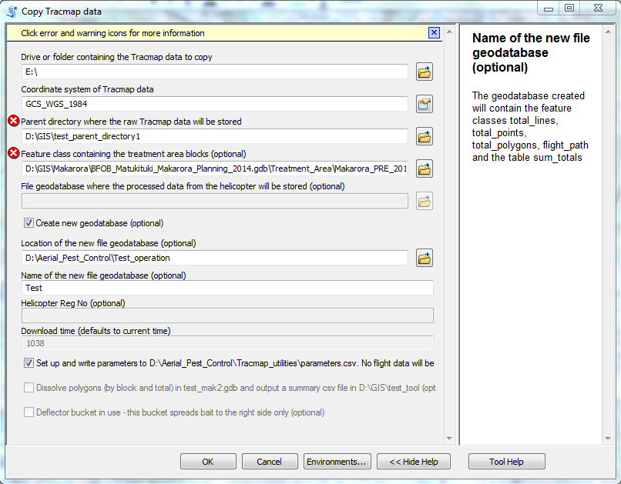

*NB: If you’re using an existing file geodatabase, if any of the required feature classes already exist, the script will rename them and create a new empty feature classes:*

* *'total_points',*
* *'total_lines',*
* *'total_polygons',*
* *'flight_path'*

*Tables:*

* *'sum_totals',*
* *'helicopter_info',*
* *'operation_start_end_time'*

1. Click OK
2. Close the Copy Tracmap Data results window.

## Refresh the toolbox

Open the Catalog window, right-click the Tracmap_utilities toolbox then select Refresh.

*NB: This step is important as it refreshes the default parameters you see when you re run the tool. If you don’t do this the tool may not be pointing to the correct location you want to work in.*

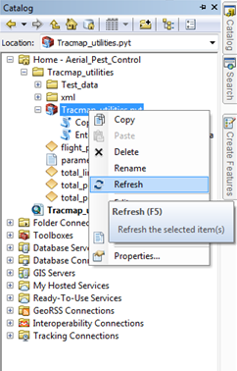

## Add Helicopter Metadata

1. In the Catalog window, double-click the “Enter or Update Operation Metadata” script.
2. In the “Enter the time the operation went Toxic” box enter a time *after* the helicopters were on site but *before* they started the sowing (both for prefeed and toxic operations). This filters out any helicopter flight path data recorded from when the helicopter leaves it’s base or pre operation boundary flight checks.
3. In the “Enter the helicopter registration number” box, enter the helicopter’s 3-letter registration number, then click on the add button. The registration number you entered will automatically be added to the table below the box.

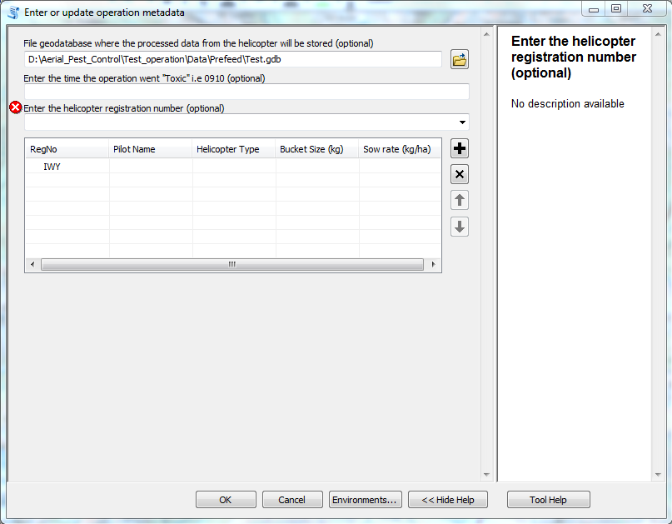

1. Repeat this process for each helicopter involved in the operation.
2. To fill out the metadata for each helicopter, click in each relevant cell within the table then enter/select the appropriate values. This step is essential and the script won’t run without it.

Tip: Pilot’s Names are entered manually. Helicopter Type, Bucket Size and Sow Rate need to be selected from the options in the dropdown box for each field. If the value you need to enter doesn’t appear in the dropdown box contact Gary Eason to have it added as an option, or use one of the default temporary values provided (e.g. Unknown or 0).

Or you can edit your version of the script, the picklist options are under a heading “# parameter 2” at approx. line 938

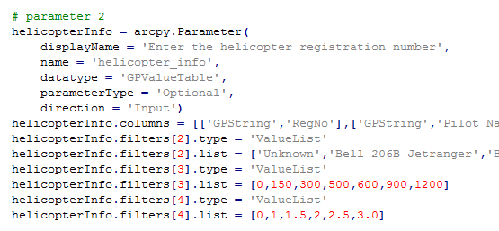

NB: The metadata values are not used in any of the calculations/processes that the tool currently does, however there must be metadata entered in all the cells for each helicopter in order for the tool to run.

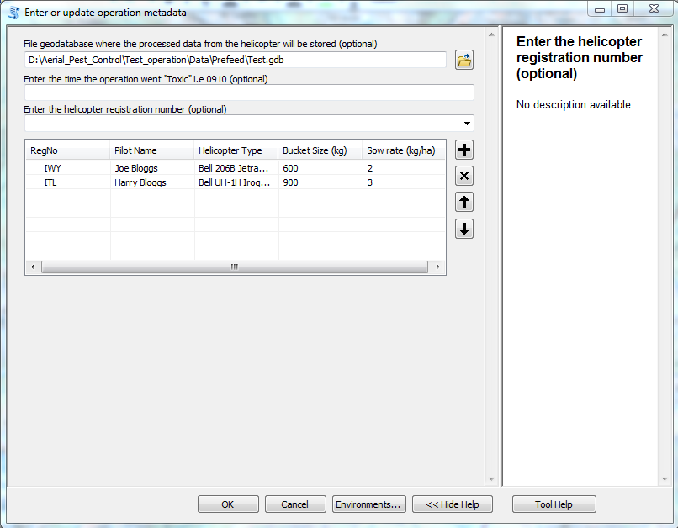

1. Click OK.
2. Close the Enter or Update Operation Metadata results window.

**ON THE DAY**

## It’s worth making a full copy of the USB stick onto your D: so there is always an original copy to go back to

## Do a quick check of the first download from each helicopter to ensure:

* WGS84
* Data is not zipped

## Run the tool each time you receive new data

Repeat the steps contained within this section each time you receive new data from a helicopter.

1. Open the Catalog window then double-click on the “Copy Tracmap Data” script in the Tracmap_utilities toolbox.

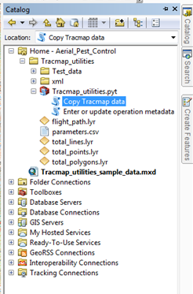

The values you entered during the tool setup phase (Step 4 above) will appear as default values in the Copy Tracmap Data dialog box, and the Download Time will default to the current time.

1. Set the first parameter to the folder above the one containing the log.shp file (as explained in previous section) Eg E:\tracmap\abbey rocks

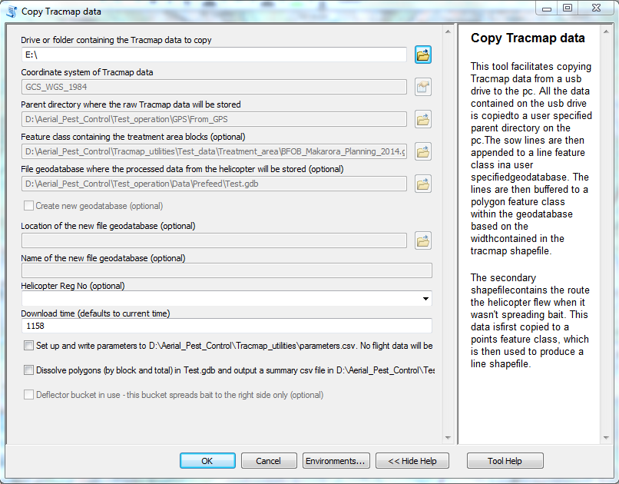

1. In the “Helicopter Reg No” box, enter (or select from the dropdown box) the appropriate 3-letter helicopter registration code.

***NB: Even though the form says optional this is NOT OPTIONAL!*** *This value is used to store the raw data in the appropriate folder structure and to populate the ‘Machine’ attribute in the output feature classes.*

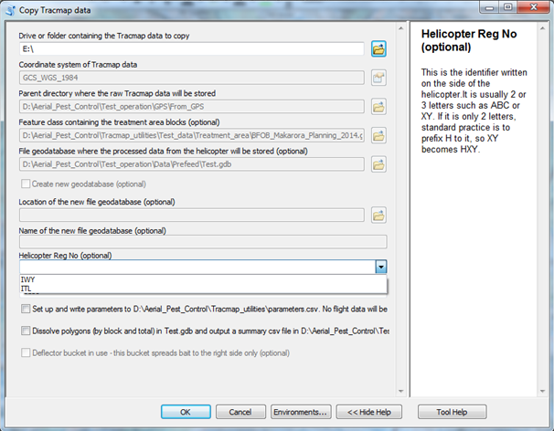

1. If the default Download Time is correct, click OK, otherwise change the time to the desired value then click OK.

Tip: When operating in the field the current time will usually be the correct value. When running the tool in the office, enter the time (24-hour format) at which the helicopter data was downloaded in the field.

*NB: This time is used to create a folder under the helicopter number so if you run the tool and a folder for the specified helicopter and time already exists you’ll get an error. You can either delete the existing folder and re run the tool, or re run the tool with a different time specifed.*

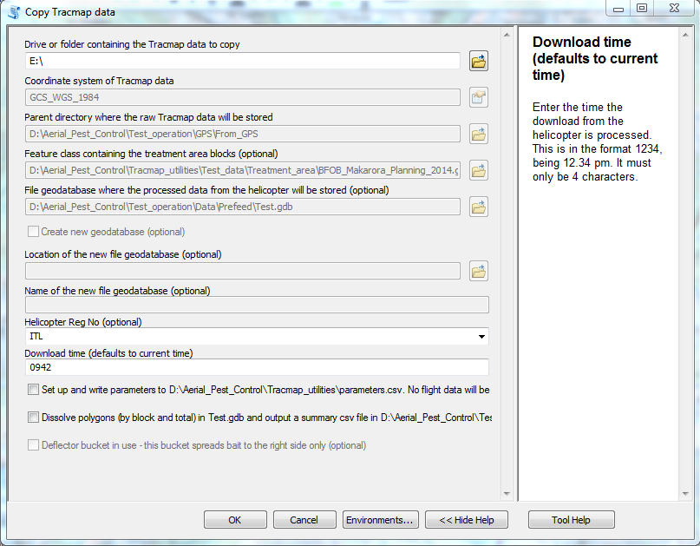

The sow areas, sow flight lines and non-sow flight lines will be displayed as shown in the example screenshot below.

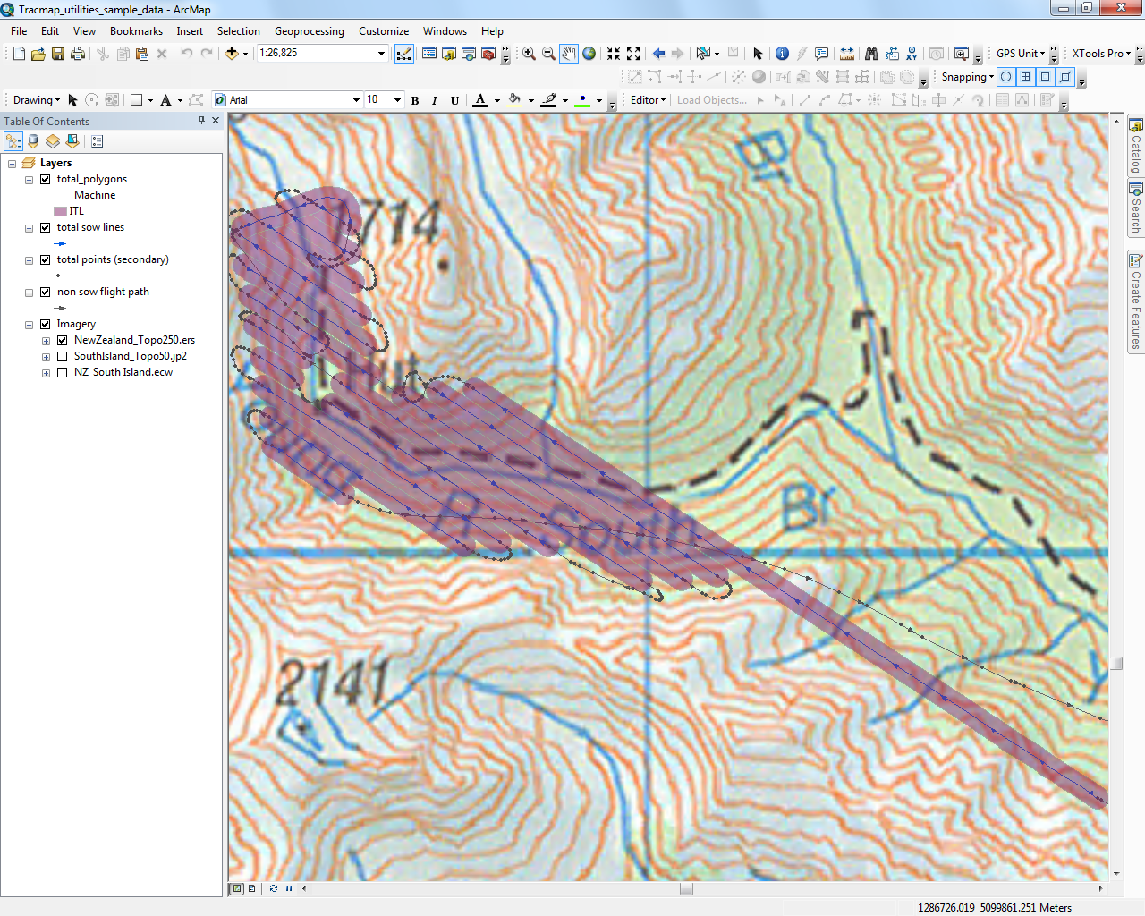

## Use the dissolve option to calculate the treated area

Use this step any time you want to calculate the treated area based on the data collected up to that point in time.

1. Open the Catalog window then double-click on the “Copy Tracmap Data” script in the Tracmap_utilities toolbox.
2. Tick the “Dissolve polygons (by block and total) in ….gdb and output a summary csv file in D:\...” box.

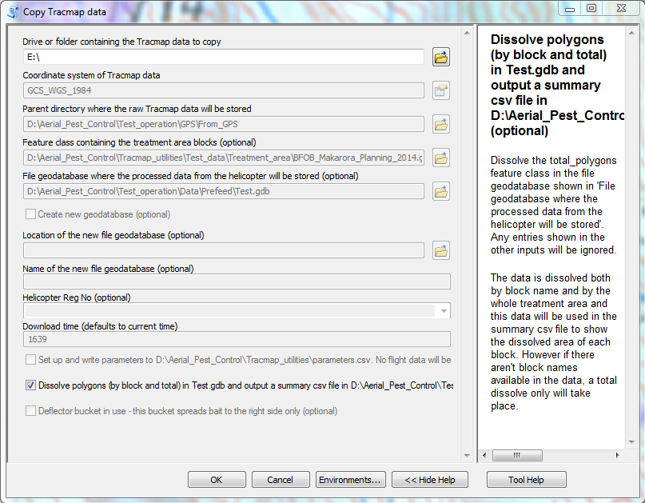

The dissolved polygons will be displayed as shown in the example screenshot below. The date and time at which the dissolve function was run are shown as part of the polygon names (2-digit month followed by 2-digit day followed by 24-hr time). The data is dissolved both by block name and by the whole treatment area. If there aren't block names available in the data only a total dissolve can take place and the “dissolved_by_block” polygon will be identical to the “total_dissolved” polygon.

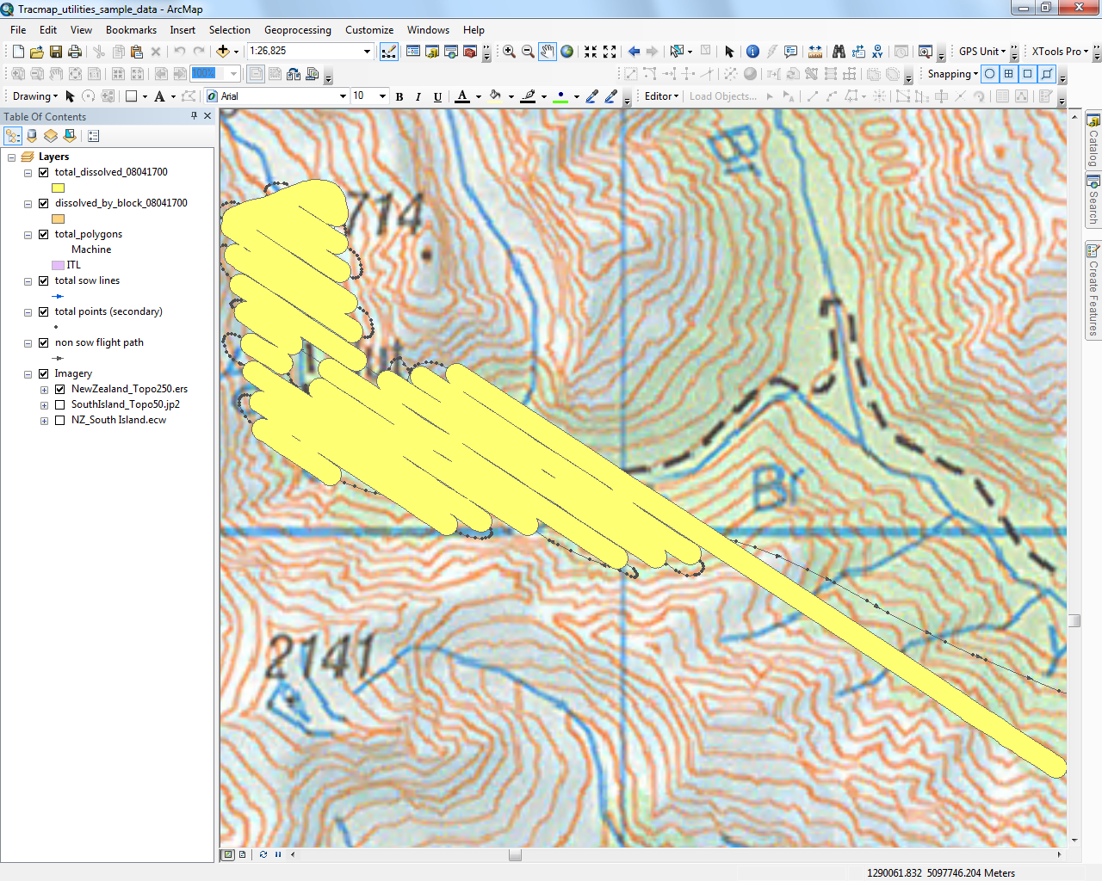

1. The treated areas (total, and by block) are stored in a summary csv file named “sum_totals” (followed by the 24-hr time at which the dissolve function was run). This file can be accessed from the Catalog window (see screenshot below). Double-click on the file name to open it in Excel.

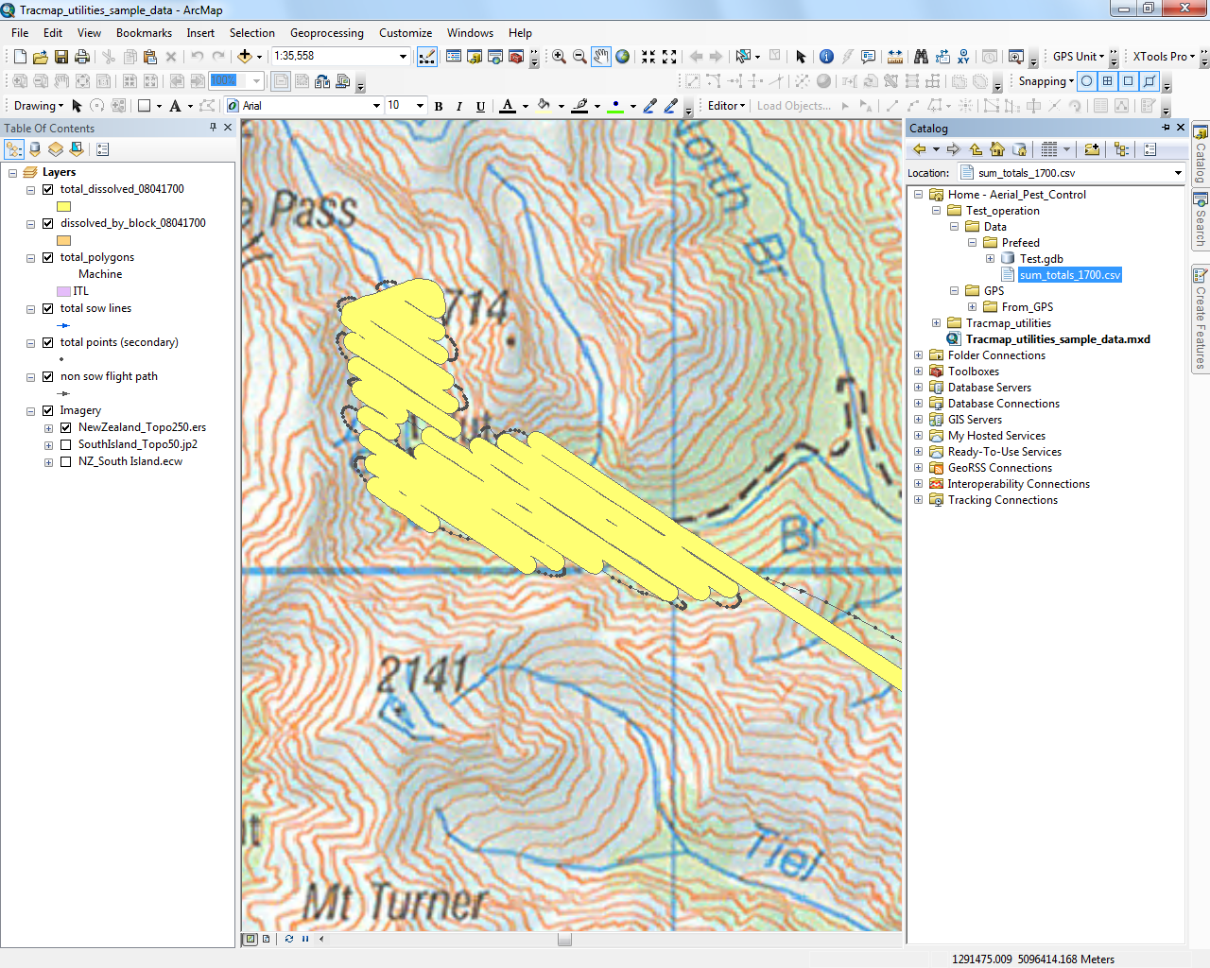

1. View the calculated treated hectares by block (Dissolved_Area column) and in total (Total Dissolved Area row), and the percentage of the treatment area that has been flown (Percentage Sown column =Hectares/Block_Area). Note that there is only one block in the example shown below.

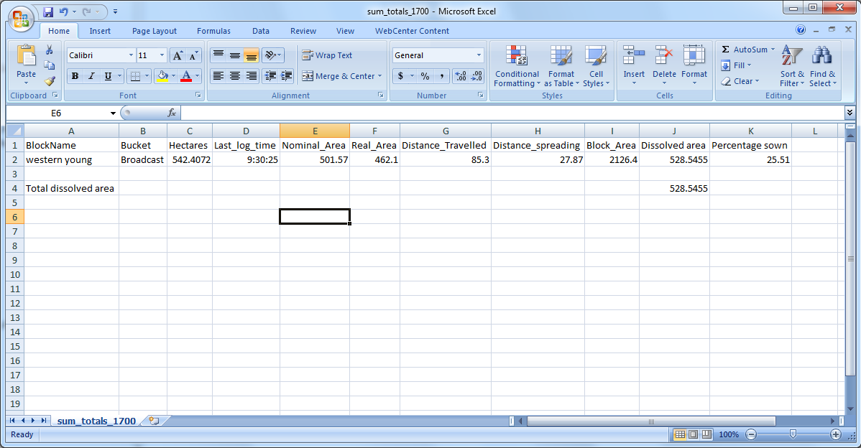

**WHEN THINGS GO WRONG**

1. Data supplied in wrong format
   1. If data is supplied in NZTM you can re project it (log and secondary files), make a copy, delete existing data then run the tool again
   2. Or you can wait for the next download, ensure it’s in wgs84 and the tool will add both sets of data at once (as long as any existing data has been deleted from the features)
   3. If the data is zipped you can copy the data manually the unzip it then run the tool.
2. Files are locked. If any of the source files are locked the tool will fail. Close your mxd and re open. This often happens if you try and re run the same load.
3. Flight paths do not symbolise correctly or total_polygon legend shows wrong helicopter code. These errors can happen if the script doesn’t fully run as the symbolisation is done towards the end of the script. The underlying data should be there and be correct so you can just go in and re symbolise the legend.
4. Error running tool

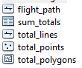The tool copies data across each time it’s run and will fail if the data already exists. So at any time if there is an error and the script doesn’t execute properly you can ‘clean the slate’ by deleting all records for that set of data from all 4 tables (shown below) and deleting the raw data folder for that time. This will enable you to run the tool again.



You can identify ‘sets’ of data to delete by selecting rows based on ‘Machine’ and ‘DL_Time’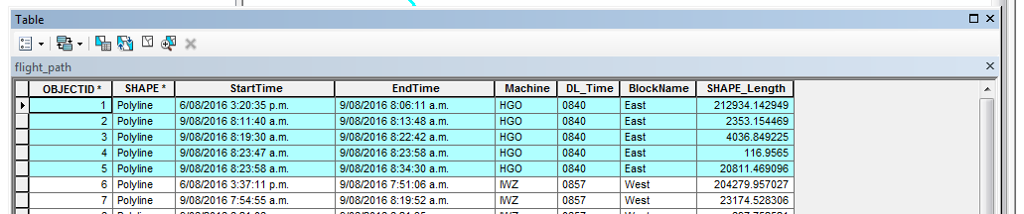

**How to work around different Boundary buffers**

The easiest way is to update the ‘Buffer’ attribute in the total_lines feature, then next time the tool is run the resulting total_polygons feature will contain the new buffers. (The tool will not override any manual changes as it never touches the data in this feature after the initial population)

* 1. 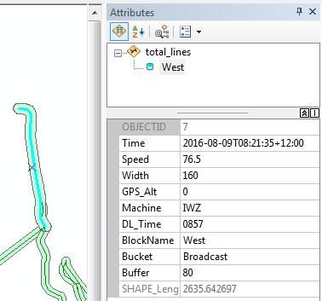Select the Total_Lines layer > Edit features > Start editing
  2. Select the lines you want to change and use the attribute window or table to update the ‘Buffer’ attribute to the new value
  3. Save and Stop editing

Below describes a method if you want to change existing buffers in the total_polygons feature:

* 1. Select the Total_Polygons layer > Edit features > Start editing
  2. Select the boundary buffer polygons you wish to change

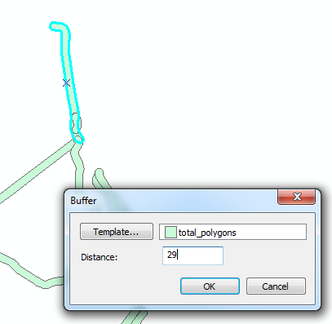

* 1. Editor > Buffer and enter in the difference ie standard broadcast buffer 80m (effective swath of 160) so add 29 to make maximum swath width of 218

*This creates additional records in the Total_Polygons file so the old/original one needs to be deleted after it’s attributes are copied.*

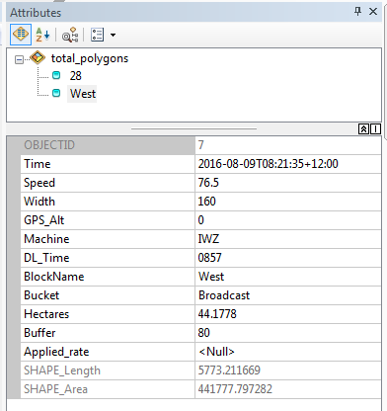

* 1. Select the pair then go to Attribute window
  2. Select the original record > right click > copy attributes (‘West’ in this example)
  3. 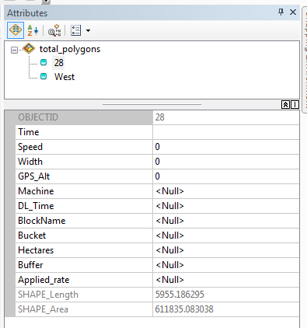Select the new one > right click > paste
  4. Select the original again > delete
  5. Save and Stop editing
  6. For consistency you probably also want to update the ‘Buffer’ value in the Total_Lines file (in this example change from 80 to 109) This ensures you can recreate the Total_Polygons layer from the Total_Lines layer if needed and not have to manually change the boundary buffer each time.